A width x height grid is on an XY-plane with the **bottom-left** cell at (0, 0) and the **top-right** cell at (width - 1, height - 1). The grid is aligned with the four cardinal directions ("North", "East", "South", and "West"). A robot is **initially** at cell (0, 0) facing direction "East".

The robot can be instructed to move for a specific number of **steps**. For each step, it does the following.

1. Attempts to move **forward one** cell in the direction it is facing.
2. If the cell the robot is **moving to** is **out of bounds**, the robot instead **turns** 90 degrees **counterclockwise** and retries the step.

After the robot finishes moving the number of steps required, it stops and awaits the next instruction.

Implement the Robot class:

* Robot(int width, int height) Initializes the width x height grid with the robot at (0, 0) facing "East".
* void move(int num) Instructs the robot to move forward num steps.
* int[] getPos() Returns the current cell the robot is at, as an array of length 2, [x, y].
* String getDir() Returns the current direction of the robot, "North", "East", "South", or "West".

**Example 1:**

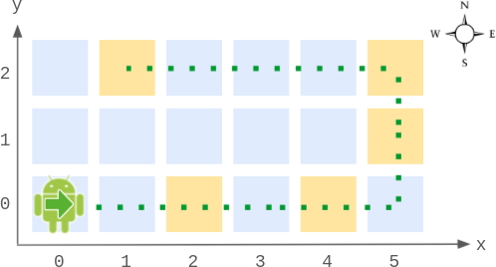

**Input**

["Robot", "move", "move", "getPos", "getDir", "move", "move", "move", "getPos", "getDir"]

[[6, 3], [2], [2], [], [], [2], [1], [4], [], []]

**Output**

[null, null, null, [4, 0], "East", null, null, null, [1, 2], "West"]

**Explanation**

Robot robot = new Robot(6, 3); // Initialize the grid and the robot at (0, 0) facing East.

robot.move(2); // It moves two steps East to (2, 0), and faces East.

robot.move(2); // It moves two steps East to (4, 0), and faces East.

robot.getPos(); // return [4, 0]

robot.getDir(); // return "East"

robot.move(2); // It moves one step East to (5, 0), and faces East.

// Moving the next step East would be out of bounds, so it turns and faces North.

// Then, it moves one step North to (5, 1), and faces North.

robot.move(1); // It moves one step North to (5, 2), and faces **North** (not West).

robot.move(4); // Moving the next step North would be out of bounds, so it turns and faces West.

// Then, it moves four steps West to (1, 2), and faces West.

robot.getPos(); // return [1, 2]

robot.getDir(); // return "West"

**Constraints:**

* 2 <= width, height <= 100
* 1 <= num <= 105
* At most 104 calls **in total** will be made to move, getPos, and getDir.